FINDING SOIL MOISTURE AND HUMIDITY USING IOT

SDG PROJECT

TEAM MEMBERS :

E.G.PRADEEP(RA2211004050026)

M.S.SAI SANKEET(RA2211004050026)

B.PRASANTH(RA22110040500

ABSTRACT:

The advent of Internet of Things (IOT) technology has revolutionized agriculture by enabling precision farming techniques. This paper proposes an IOT-based agricultural sensor system designed to enhance crop management practices through real-time monitoring of soil conditions. The system utilizes a network of wireless soil sensors deployed across agricultural fields to collect data on key parameters such as soil moisture, temperature, pH levels.

INTRODUCTION:

Smart farming technologies have empowered farmers which help them to compete with significant problems they face through much better remedies. The growth pattern and environmental parameters of crop growth provide scientific guidance and optimum countermeasures for agricultural production. The proposed system uses a IOT and an array of sensors LIKE pH sensor, and capacitance dielectric soil moisture sensor, and is more accurate than existing systems in tracking the soil contents and the security of the crops.

MOTIVATION

**With IOT technology, farmers can remotely monitor soil conditions from anywhere using smartphones or computers. This capability allows for timely interventions and adjustments, even when farmers are off-site.**

**EXSITING METHODOLOGY:**

**<https://youtu.be/T3t296-qpGc?si=Pjply7KqxwgIrVYD>**

**<https://youtu.be/nqrbCnzTrDM?si=f0tCL1Xk6nWQu3_I>**

**PROPOSED METHODOLOGY:**

**1. Sensor Selection: Choose appropriate sensors for measuring soil moisture and humidity. Capacitive soil moisture sensors and DHT series sensors (such as DHT11 or DHT22) are commonly used for this purpose.**

**2. Hardware Setup: Connect the sensors to a microcontroller board such as Arduino or Raspberry Pi. Ensure the sensors are properly wired and powered.**

**3. Data Acquisition: Program the microcontroller to read data from the sensors at regular intervals. For example, you can read soil moisture and humidity values every hour.**

**4.Data Transmission: Use an IoT module (like ESP8266 or ESP32) to transmit the sensor data to the cloud. You can use protocols like MQTT or HTTP to send the data.**

**5. Cloud Storage: Set up a cloud service (like AWS IoT, Google Cloud IoT, or Azure IoT Hub) to receive and store the sensor data. Configure the cloud service to handle incoming data from the IoT module.**

**6. Data Analysis and Visualization: Use cloud-based data analytics tools or platforms (such as AWS IoT Analytics or Google Cloud Dataflow) to analyze the collected data. Visualize the data using dashboards (like Grafana or custom web dashboards) to monitor soil moisture and humidity levels over time.**

**7. Alerting System: Implement an alerting system to notify users when soil moisture or humidity levels deviate from predefined thresholds. You can use email notifications, SMS alerts, or push notifications through a mobile app.**

**8. Data Interpretation and Action: Based on the analyzed data, take appropriate actions such as adjusting irrigation schedules, activating sprinkler systems, or notifying farmers to take corrective measures.**

**9. Maintenance and Calibration: Regularly check and calibrate the sensors to ensure accuracy. Also, monitor the overall system for any issues or malfunctions.**

**10. Integration with Other Systems: Optionally, integrate the soil moisture and humidity data with other agricultural systems, such as weather forecasts or crop management software, to enhance decision-making processes.**

**RESULTS:**

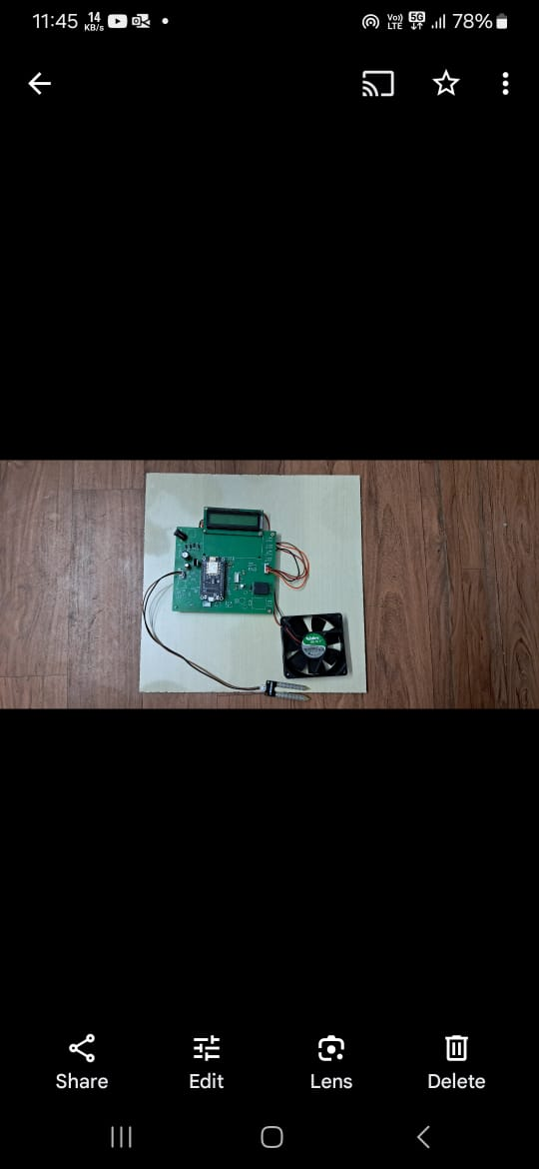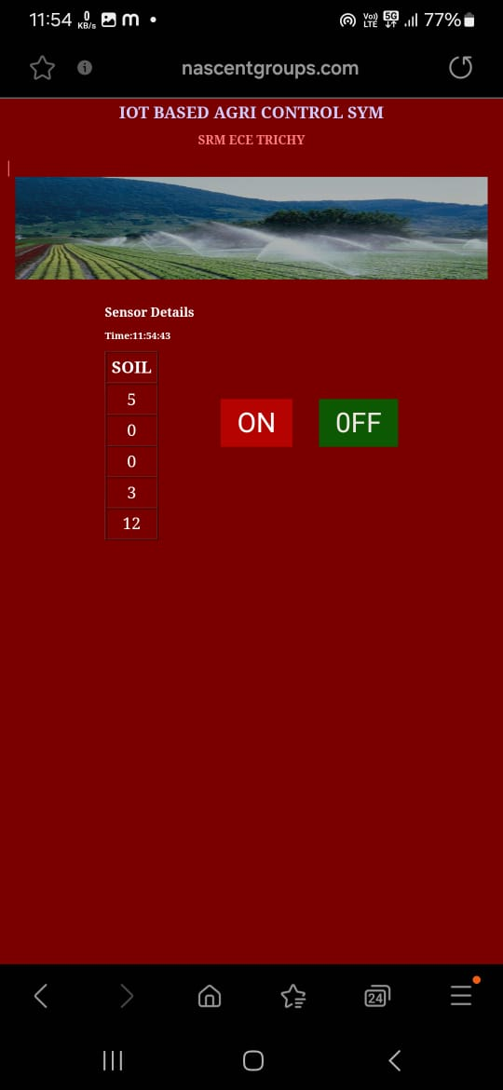

**CONCLUSION:**

**Thus we concluded that** IOT sensors measure soil parameters such as moisture content, temperature, pH levels, and nutrient concentrations. This data helps farmers optimize irrigation schedules, assess soil fertility, and make informed decisions about fertilizer application.

**REFERENCES :**

**Agricultural Informatics, Automation using IOT and Machine learning, Edited by Amitava Choudhury, Arindam Biswas, Manish Prateek, Amlan chakrabarti.**